12.20: Get g on the neutron star

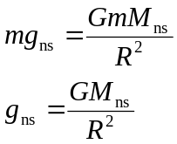
Your weight would be
